|  |  |  |  |  |  |
| --- | --- | --- | --- | --- | --- |
| Date | 2-Dec-22 | | | Tester Name | Andrew McLaughlin |
| Environment | Penfax - Test | | | Login used |  |
| Operating System | Select OS | Version: | Update: | | |
| Software Used | Select Software | Version: | Update: | | |
| Select Software | Version: | Update: | | |
| Release version | 22.4.1 | | | | |
| Title | Designated member eligible for normal retirement | | | | |
| Test Type | Regression | | | | |
| Test Scenario | Designated member eligible for normal retirement | | | | |
|  |  | | | | |
| Expected Results |  | | | | |
| Pass/Fail | Pass | | | JIRA# | N/A |

Describe your steps with screenshots:

Member deferred and Calculated Service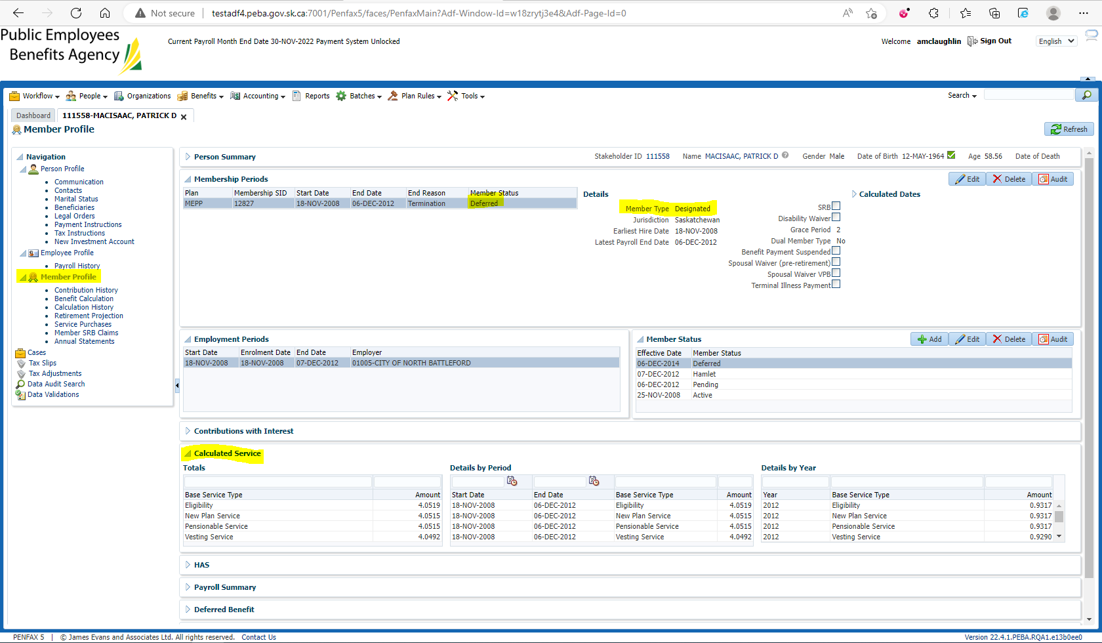

Benefit Calculation>Pick 1st of next Month for Retirement Date>Calculate 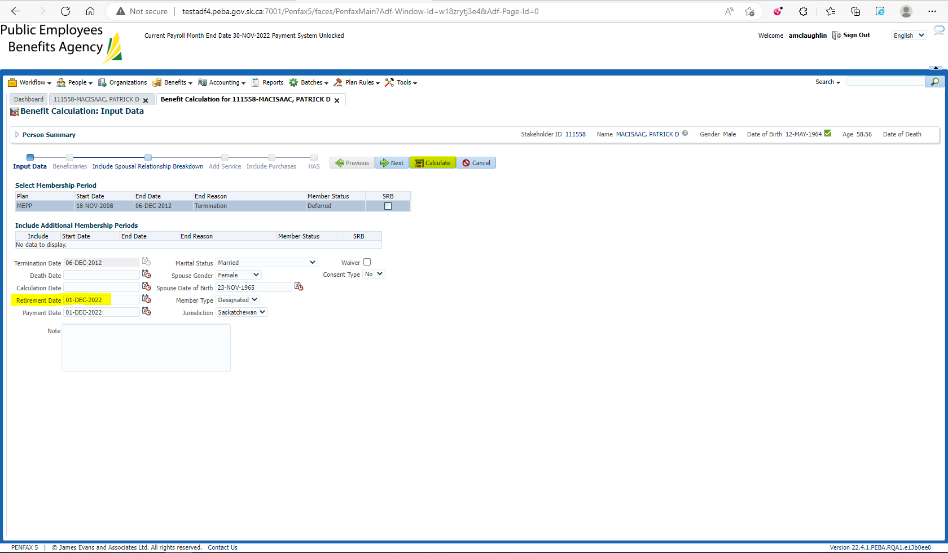

Process 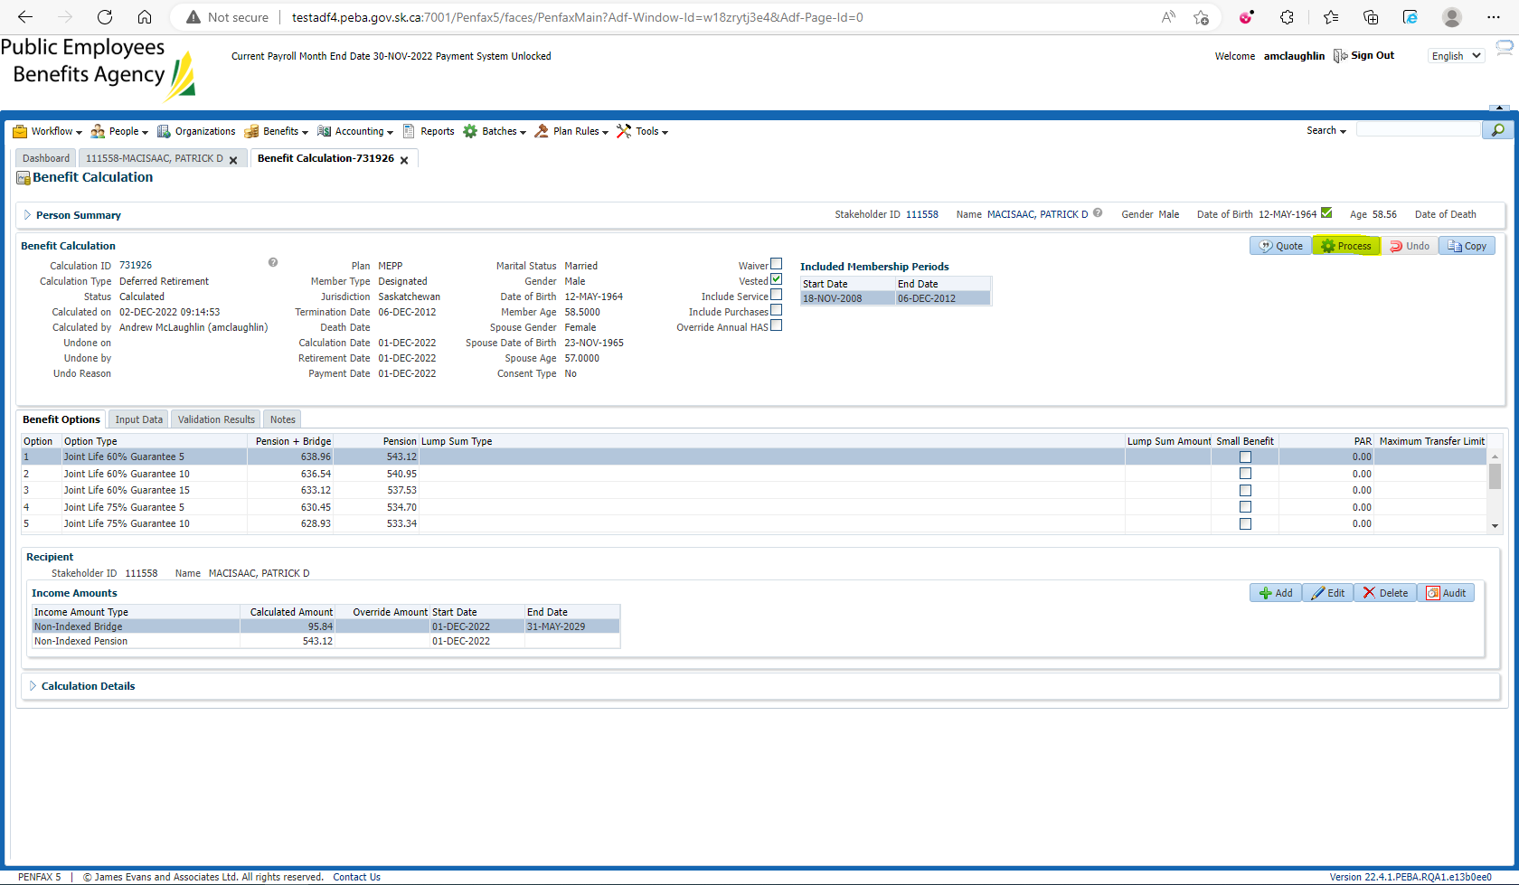

Processed

To Benefit Selection

Next 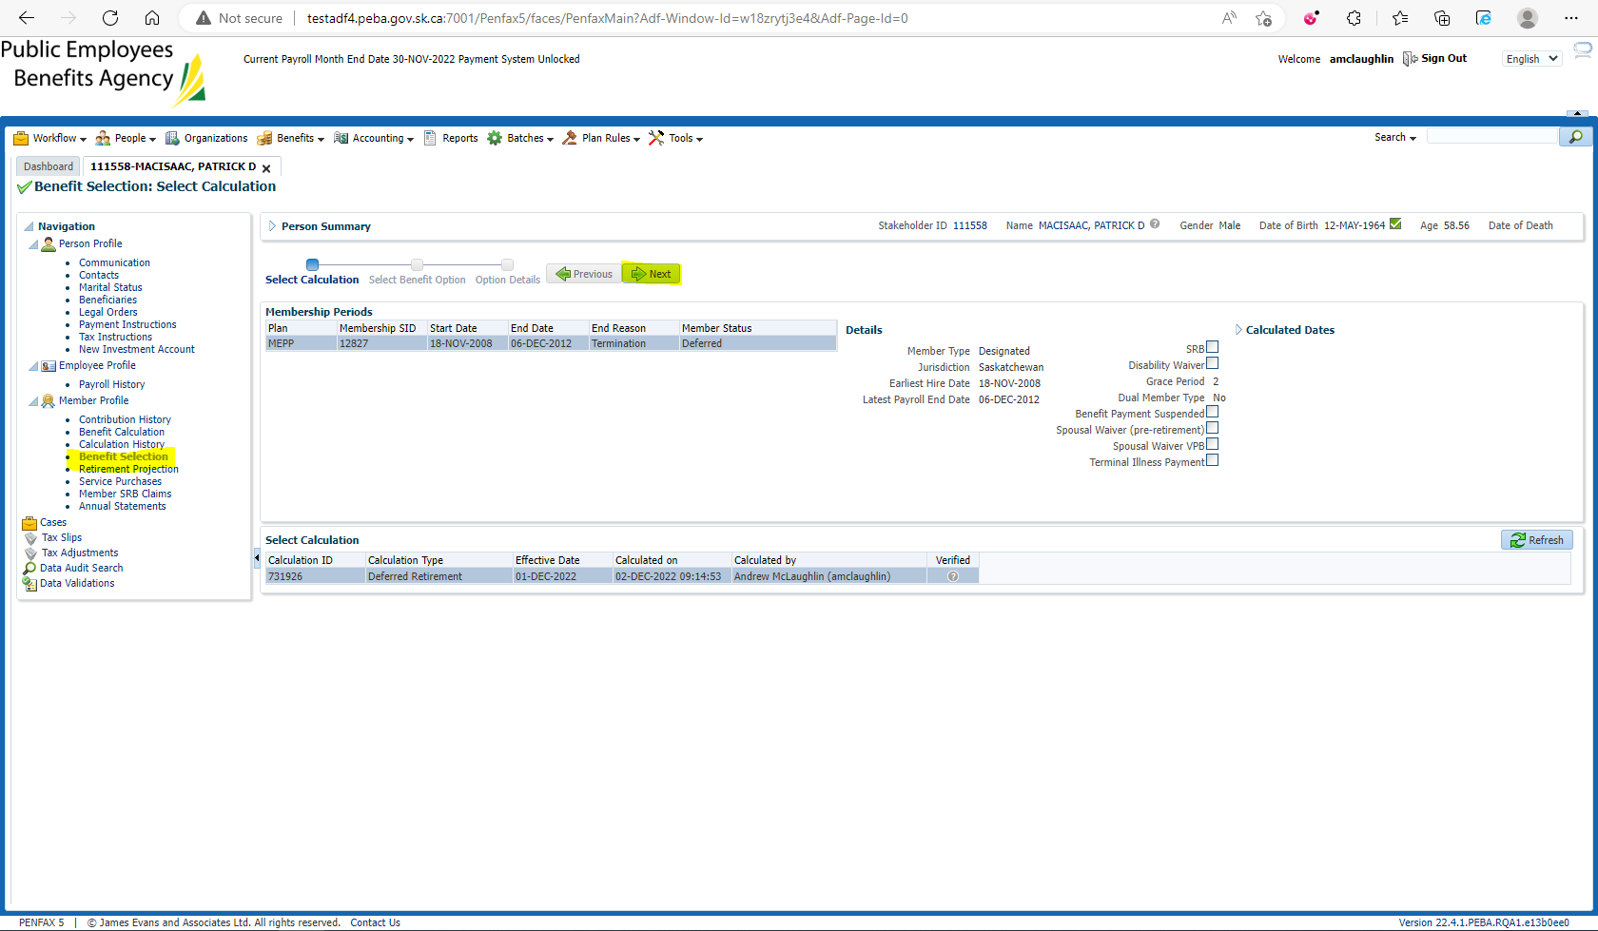

Add future Payment Date> Next 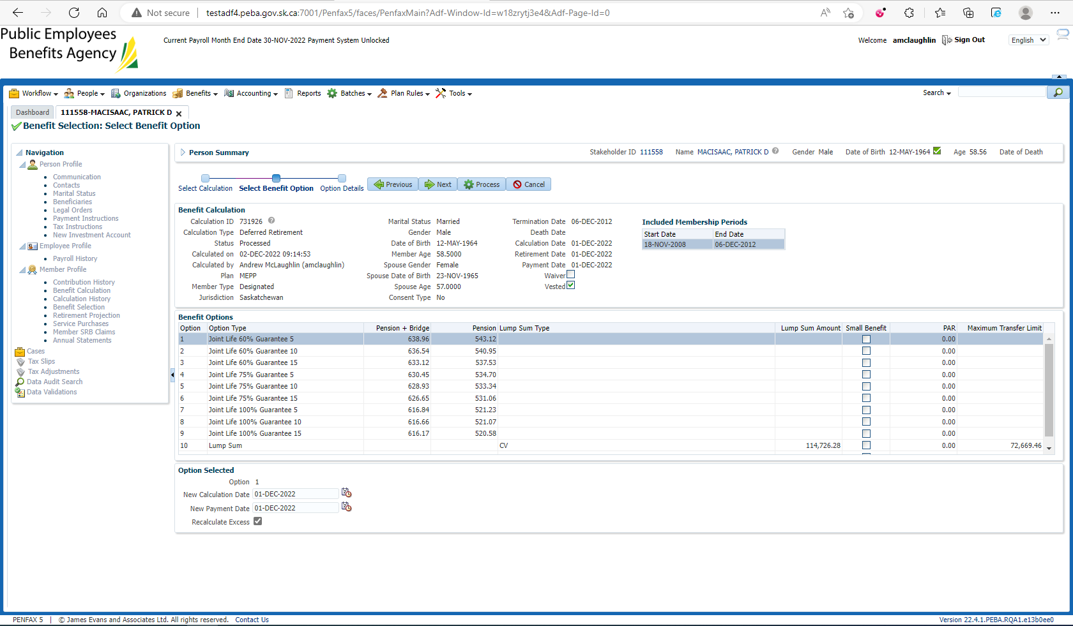

Add Payment Instructions, Note the Start Date, and Process 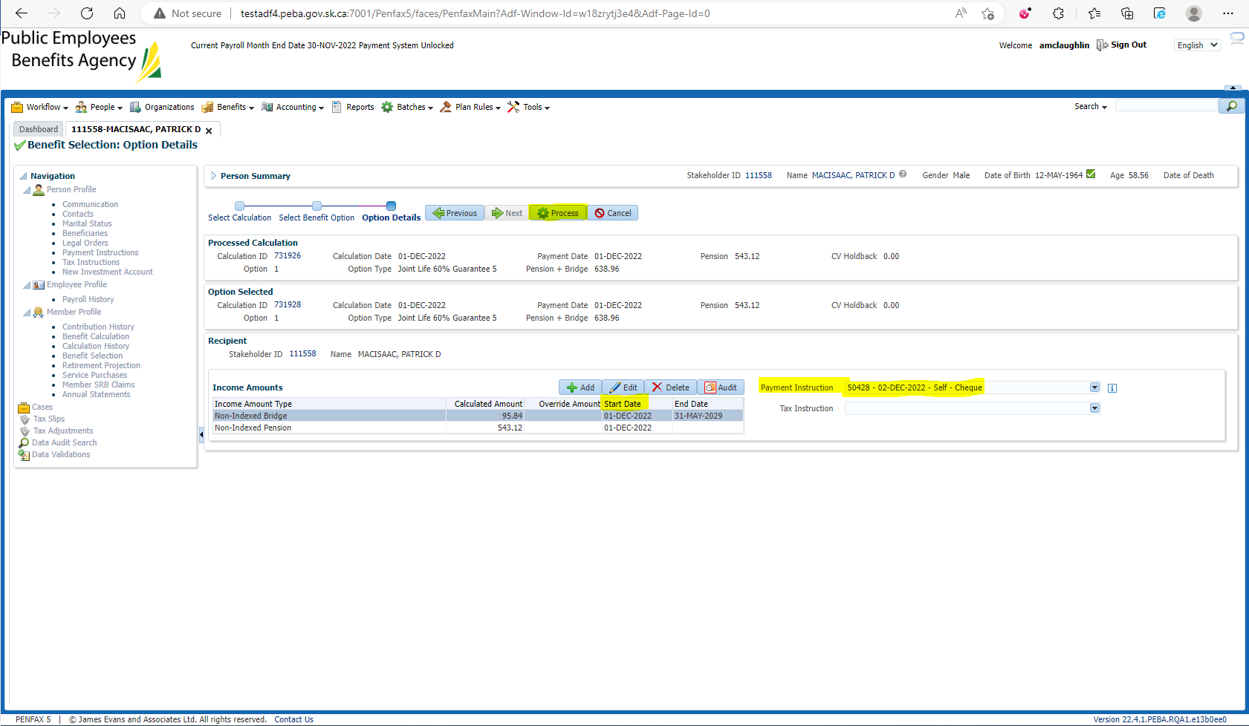

Member status is Pensioned and Calculated Service matches